**Module 2: VBA Editor Environment**

* What is VBE?

The **Visual Basic Editor (VBE)** is the programming environment in Microsoft Office applications (like Excel, Word, PowerPoint, Access, Outlook) where you write, edit, and run **VBA (Visual Basic for Applications)** code.

How to Access VBE?

1. Open Excel/Word/PowerPoint.
2. Press **Alt + F11** → opens VBE.
3. Or enable the **Developer Tab** → click on **Visual Basic** button.

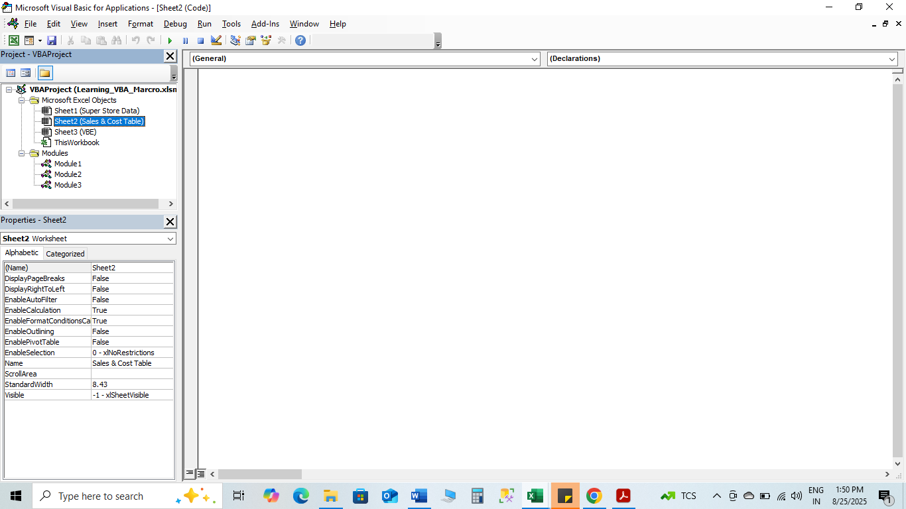

Key Components of VBE

* **Project Explorer (Ctrl + R)**

The Project Explorer in VBA is a window within the Visual Basic Editor (VBE) that provides a hierarchical view of all open VBA projects and their components.

* Shows all open workbooks/documents and their VBA components (Modules, UserForms, Sheets, etc.).
* Lets you navigate and organize your code.

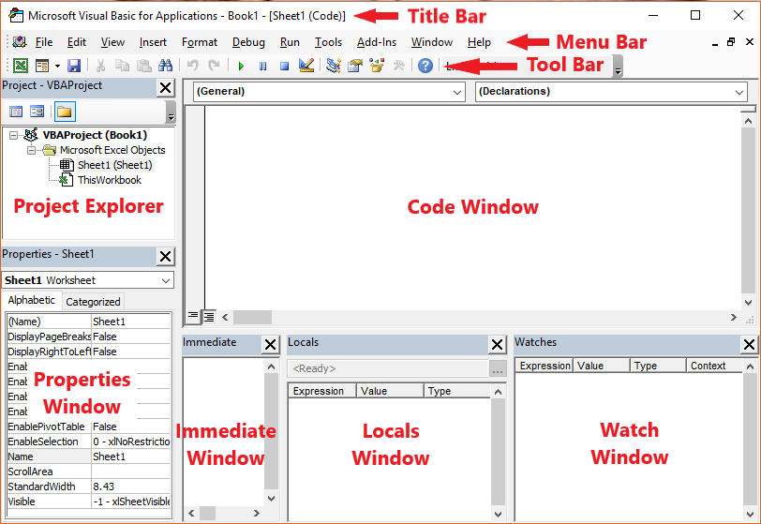

**(Note:-Go to view to open immediate window, Locals window, watch window)**

* **Code Window**
* Where you write and edit VBA code.
* **Immediate Window (Ctrl + G)**
* For testing/debugging single lines of code instantly.
* Example: typing ? 10*5 returns 50.
* **Properties Window (F4)**
* Displays and allows editing of properties of objects (like worksheets, forms, controls).
* **Menu & Toolbar**
* Provides commands for running, debugging, inserting modules, or setting references.

**Use of immediate window, local window, watch window**

Immediate Window → Test code & print values quickly.

Locals Window → See all variables in the current scope at once.

Watch Window → Track selected variables or conditions, with auto-break options.

Example-1 (Excel VBA in VBE)

Sub HelloWorld()

MsgBox "Hello, Amit! Welcome to VBA."

End Sub

Paste this into a **Module** inside VBE and run it → a message box will pop up.

Example-2

Sub HelloWorld()

MsgBox "Hello, Amit! Welcome to VBA."

MsgBox "I am Learning VBA"

End Sub

* **Understanding Modules & Procedures**

A **Module** is like a container (a file) inside the VBA Project where you can write your macros (procedures).

* When you record a macro, Excel usually saves it in a **Module**.
* Modules can hold **Procedures (Subs and Functions)**.
* Think of a **Module** like a notebook, and each **Procedure** is a page of code inside it.

**Types of Modules:**

* **Standard Module** – General place to store macros (e.g., Module1, Module2).
* **Class Module** – Used to create objects and define their behavior.
* **Object Modules** – Tied to objects (like ThisWorkbook, Sheet1) where you can write event-driven macros (like Workbook_Open).

Go to VBE than double click on Thisworkbook, than select workbook in object, and select sheetchange in procedure

MsgBox "You have change in sheet"

**UserForm Module- Go to Microsoft Excel Object than right click, than go to insert and select UserForm**

**For toolbox in UserForm go to view and Toolbox.**

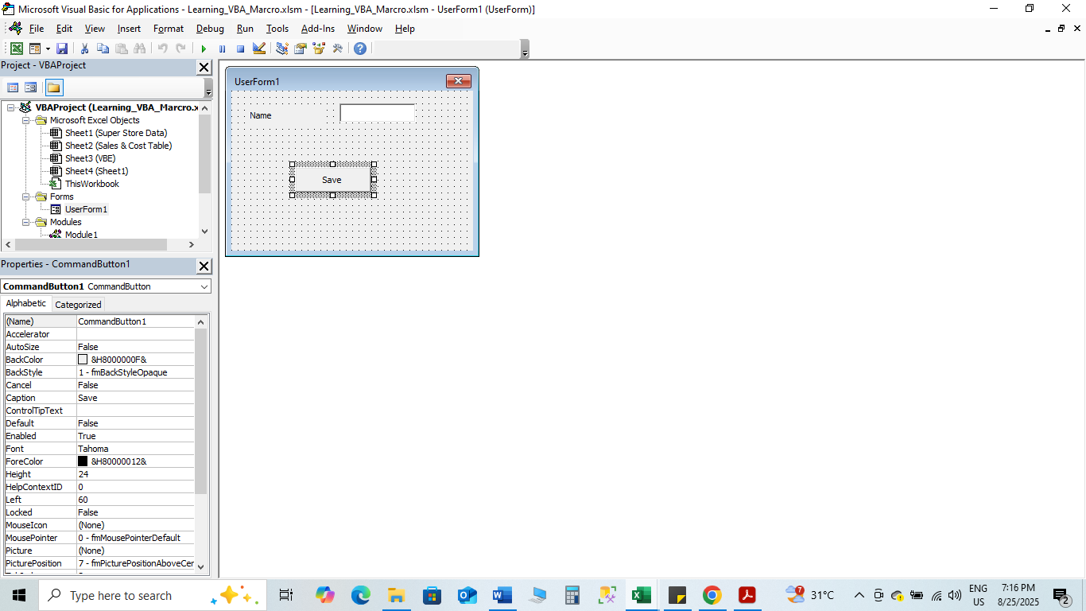

UserName = TextBox1.Text

Sheets("sheet1").Range("a1").Value = UserName